My content Part

1. ***Our products (2line)-***

*From health and hygiene to fashion and accessories, we deal with all the products including apparel, fashion items, makeup products, household products, and many more, but the main ones we deal with, are leather products. We aim at assuring quality and customer satisfaction with world-class brand products.*

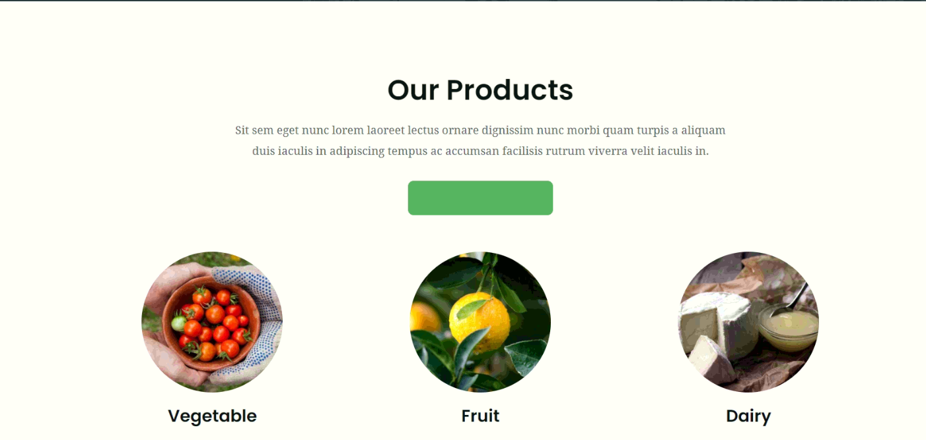

1. ***our services***

* ***Warehousing two to three line***

1. *We provide warehousing services with extra storage and enhanced security assurance for all kinds of products and goods storage. Warehouses are the necessities for the suppliers as well as the merchants, and we help resolve the same.*
2. *Warehouses are meant for goods storage, and they are required across the year, hence it is a must for them to have climate control features with the highest security and a wide storage area for better support. We assure all the points necessary with our world-class warehousing services.*

* ***B2B***

1. *We offer secure and trusted services for business to business connections and relations in a supply chain involving the suppliers, manufacturers, retailers, and all the entities involved. We ease the supplies of raw materials and manufactured products from suppliers to manufacturers and then to retailers with a smooth flow.*
2. *B2B connections are the most crucial ones in the production of any goods, and we assure the best relationship management between various entities involved in a supply chain, with the world-class B2B services. We have the most flexible service for all the needs and requirements.*

* ***Manufacturer***

1. *We have relations with top manufacturing brands like Puma, Optis, Spykar, and several more, and we mainly deal in leather products. We also provide manufacturing and importing services for various household items worldwide.*
2. *Manufacturing the high-quality goods including leather products like spacious bags and household goods are among the top services that we offer. We assure affordable prices for our goods and also provide worldwide imports for them.*

* ***Ecommerce***

1. *E-commerce services are meant for empowering the retailers and easing the shopping headaches for the buyers. We have a giant connection base with the top E-commerce websites that aim at assuring the best quality products with on-time deliveries. With these, we provide the best digital shopping platforms for our clients with exclusive offers.*
2. *E-commerce is a widely thriving sector with multiple platforms available. They promise for ensuring high-quality and on-time deliveries, and the platforms partnered with us turn out to fulfill all the promises. From clothing to appliances, we have connections with services offering a wide range of products.*

* ***Real Estate***

1. *Searching for the right property at the right location, fitting your budgets is no more a headache and matter of exerting travelings now, as we offer the best property revivals to ease the hiring and buying of them at the location of your choice.*
2. *Want to buy or rent some piece of property at a certain location? No more hassles are involved now, as we have the best real estate services. You just need to insert the budget and the choice location, and here we are with the best ones for your interest.*

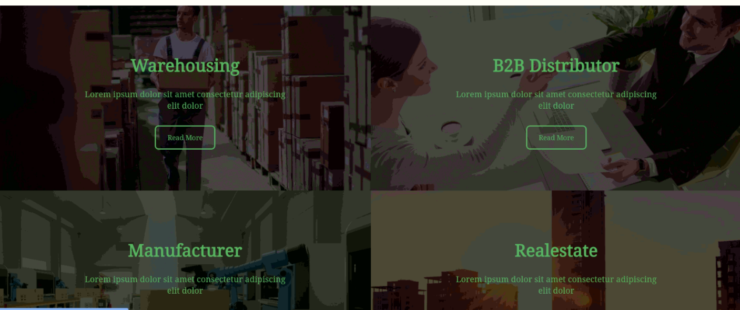

1. ***Testimonial***

***1 testimonial- Kuchbhilikh do bhut acha log hai professional hai also the variety of services. Human touch hai***

*I am highly satisfied with their ways of working and easing the task for the clients. They not only work for the sake of customer services but also aim at assuring the best relationships. They are passionate about their work and I appreciate their kind behavior along with politeness and creativity. They are also very professional and never create any nuisance, and are flexible too as they provide 24/7 support. They maintain transparency in the mode of working too and never charge excessive amounts and high commissions for any service.*

1. Our team- a small excerpt

*We have a team of top experts in every field with X+ years of experience. Our team is highly creative and polite, and they are selected after a layer of tests that ensures their quality and expertise. Our team is flexible too and they always look for newer opportunities to expand their aura. They always look forward to challenges and never step back at any unseen situation, instead, they work passionately and with high determination to resolve any issue and pass any hurdle stopping their way.*

1. Get in touch, (1 para small)

*We provide round the clock assistance and services to resolve any issue and come up with the best solutions. For any information or discussion, please reach out to us at any of our social media handles, or drop us a mail regarding the same. You can also contact us in the calling number in case of any urgent issues and get the best solutions from our expert advisors. Feel free to reach out to us, as we believe in customer satisfaction, and we are there for our clients always.*

1. 